**NAME: GODFREY CHILEBE**

**TASK: SQL INDIVIVUAL PROJECT WEEK 4**

**Question One.**

What are the total sums of freights of ship cities that have 30 or more customers?

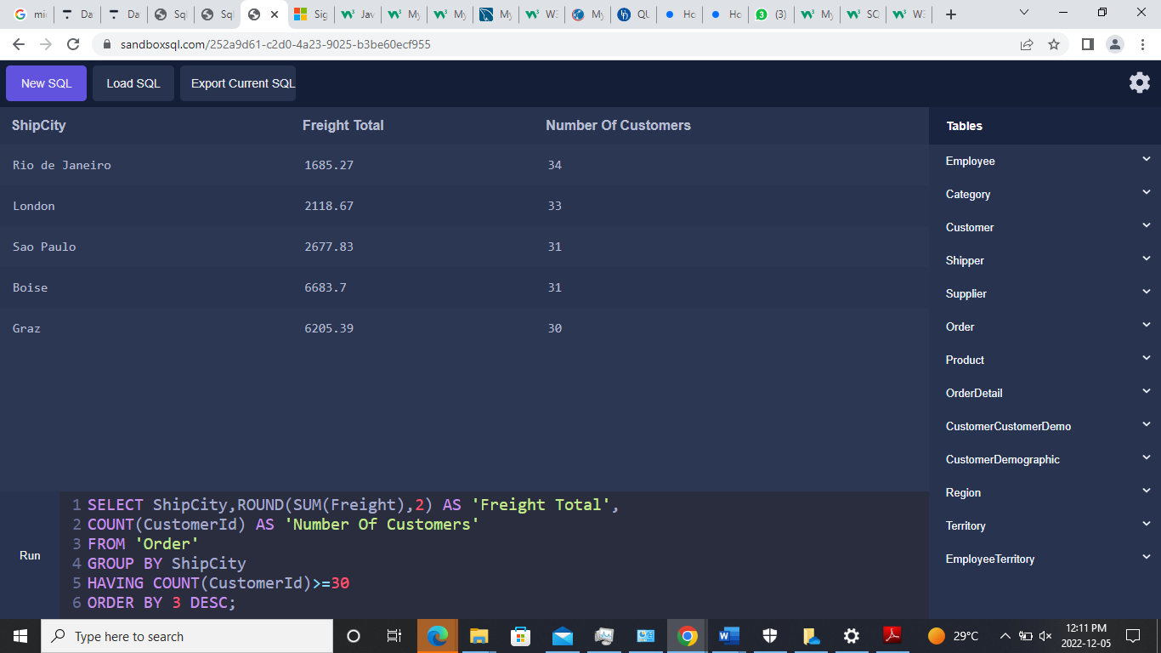

**Question Two**

Generate a table of employees and the number of customers they handle

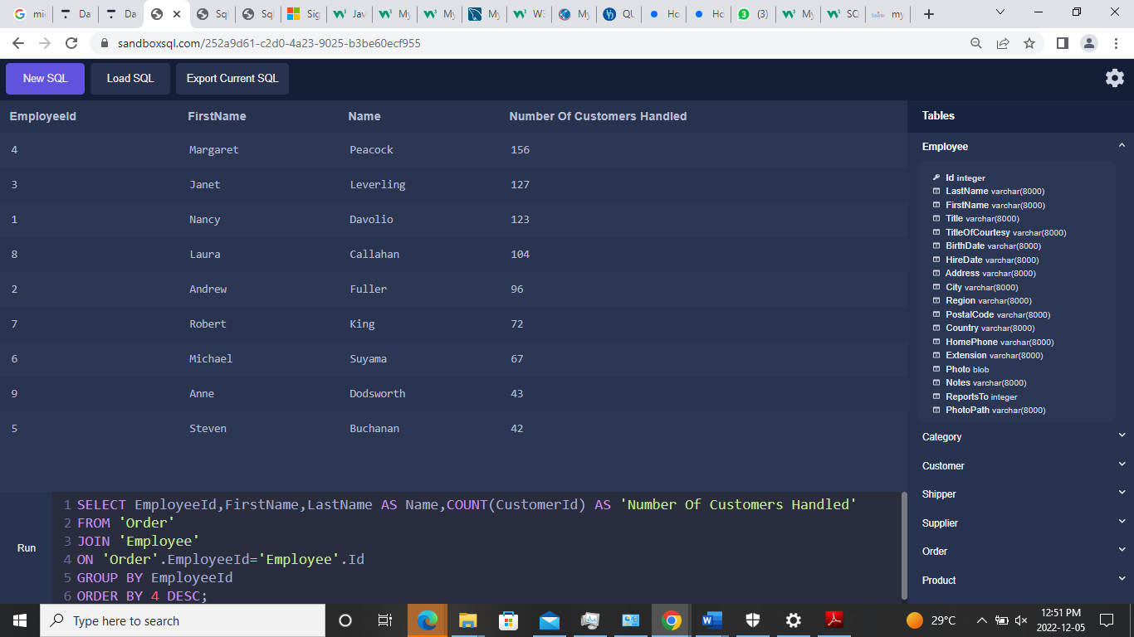

**Question Three**

How many orders were made each year?

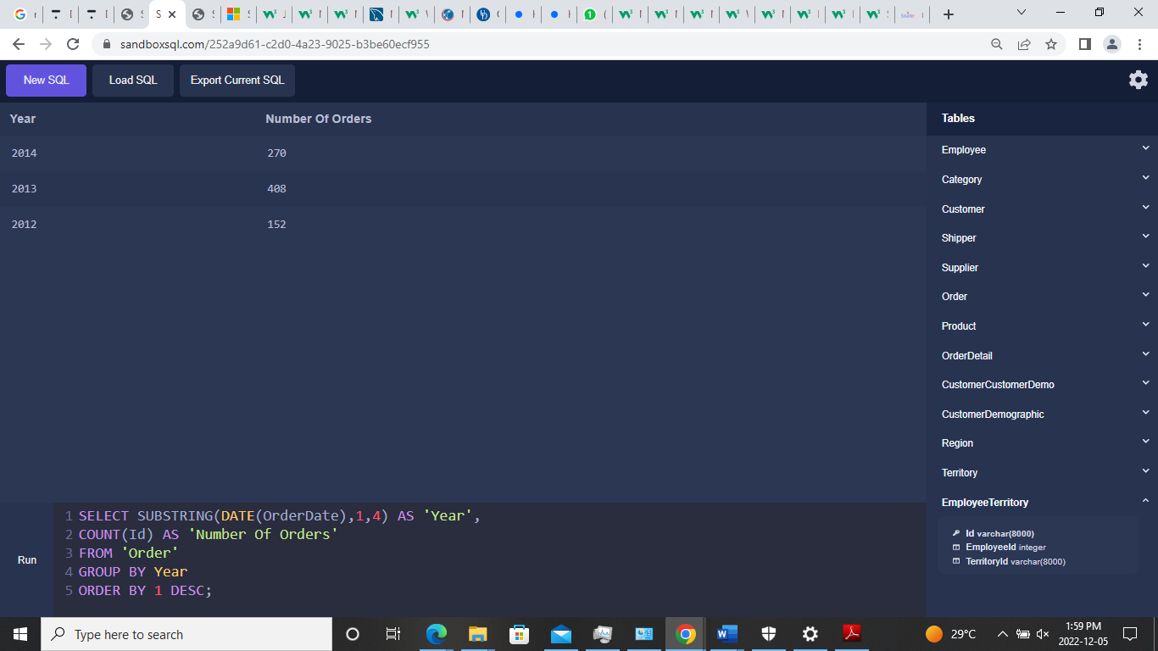

**Question Four**

What quantity of the product ‘**Chang**’ was shipped in 2014?

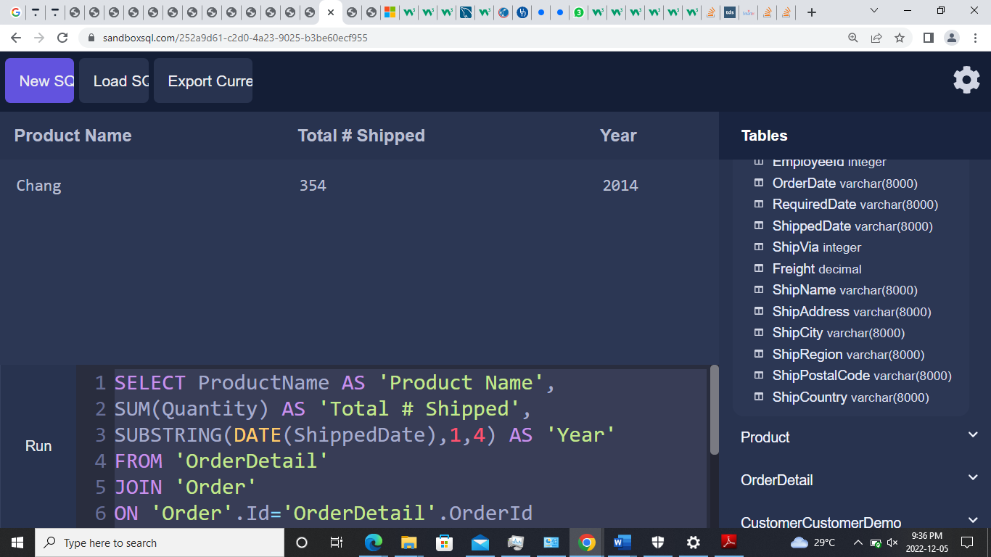

**SELECT ProductName AS 'Product Name',**

**SUM(Quantity) AS 'Total # Shipped',**

**SUBSTRING(DATE(ShippedDate),1,4) AS 'Year'**

**FROM 'OrderDetail'**

**JOIN 'Order'**

**ON 'Order'.Id='OrderDetail'.OrderId**

**JOIN 'Product'**

**ON 'Product'.Id='OrderDetail'.ProductId**

**AND Product.ProductName='Chang'**

**WHERE Year="2014"**

**ORDER BY 1 DESC;**

Question Five

What are the revenues per supplier in 2013 before and after discount applied? Show both values in a single table.

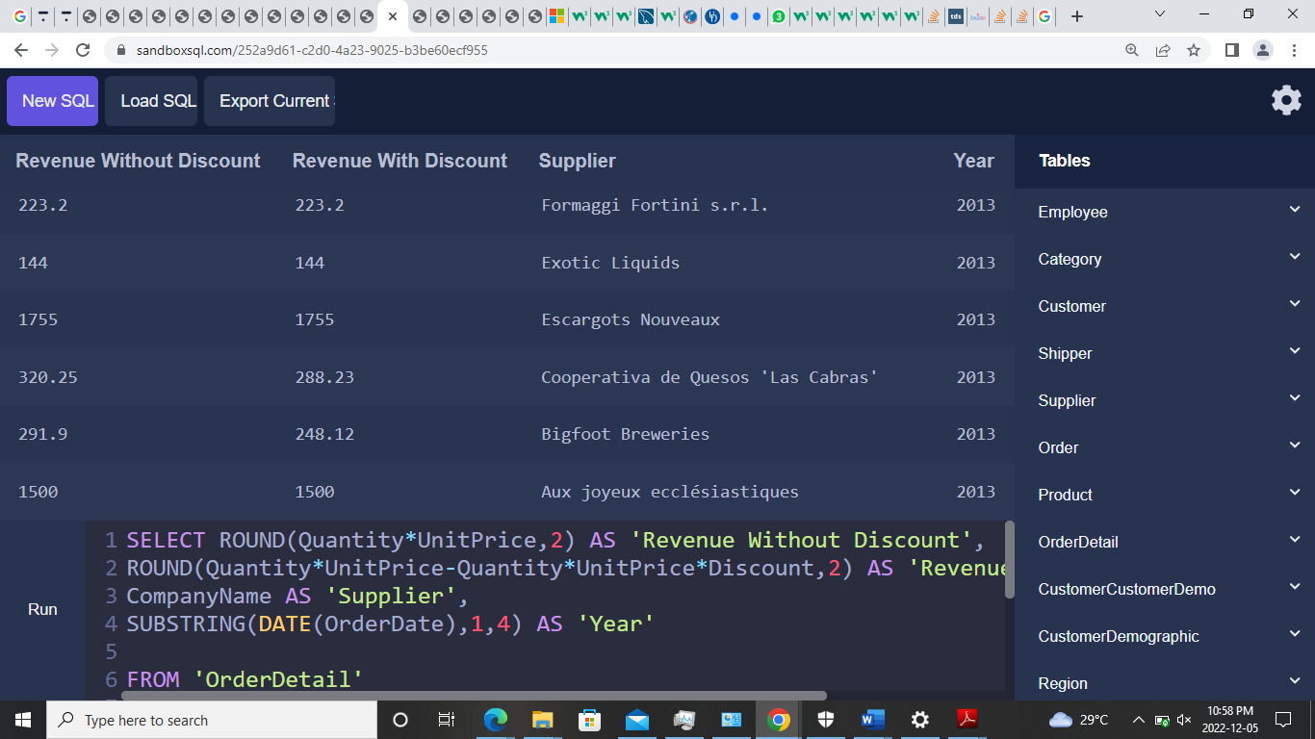

**SELECT ROUND(Quantity*UnitPrice,2) AS 'Revenue Without Discount',**

**ROUND(Quantity*UnitPrice-Quantity*UnitPrice*Discount,2) AS 'Revenue With Discount',**

**CompanyName AS 'Supplier',**

**SUBSTRING(DATE(OrderDate),1,4) AS 'Year'**

**FROM 'OrderDetail'**

**JOIN 'Supplier'**

**ON 'OrderDetail'.ProductId='Supplier'.Id**

**JOIN 'Order'**

**ON 'Order'.Id='OrderDetail'.OrderId**

**WHERE Year='2013'**

**GROUP BY 3**

**ORDER BY 3 DESC;**

**Alternative With Other Details**

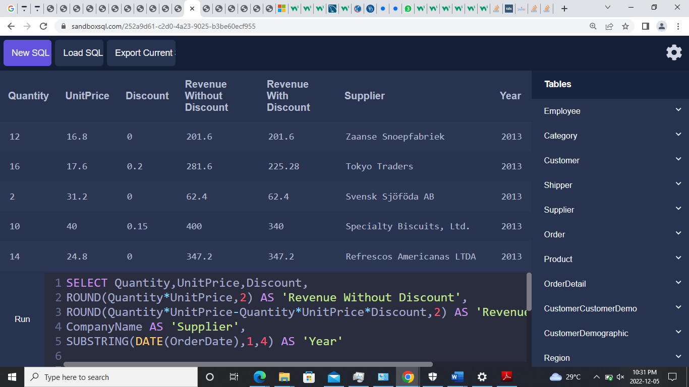

**SELECT Quantity,UnitPrice,Discount,**

**ROUND(Quantity*UnitPrice,2) AS 'Revenue Without Discount',**

**ROUND(Quantity*UnitPrice-Quantity*UnitPrice*Discount,2) AS 'Revenue With Discount',**

**CompanyName AS 'Supplier',**

**SUBSTRING(DATE(OrderDate),1,4) AS 'Year'**

**FROM 'OrderDetail'**

**JOIN 'Supplier'**

**ON 'OrderDetail'.ProductId='Supplier'.Id**

**JOIN 'Order'**

**ON 'Order'.Id='OrderDetail'.OrderId**

**WHERE Year='2013'**

**GROUP BY 6**

**ORDER BY 6 DESC;**